Ebike For Sale
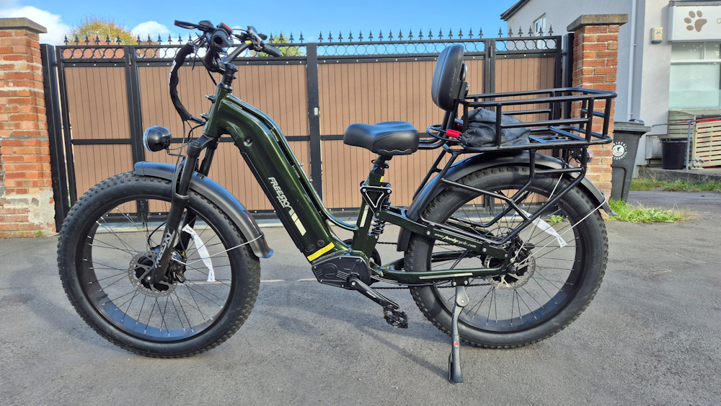
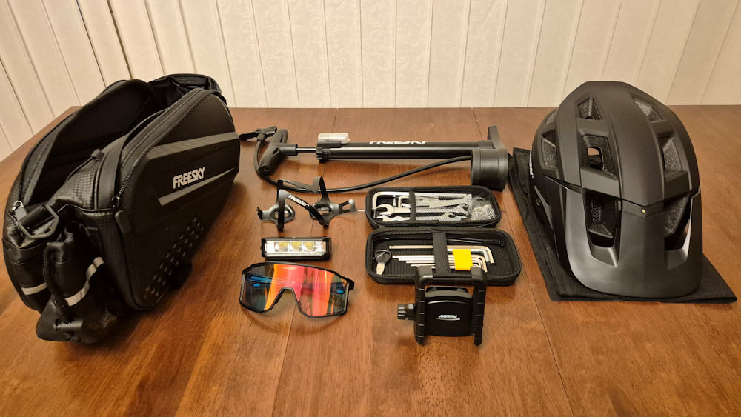 | • Nearly new Freesky Ranger Air ebike  • 126 miles only  • Fully built - ready the day you collect it  • Comes with basket, two locks, helmet, toolkit and more  • Really comfortable - wide seat with a back rest  • Effortless - thumb throttle when you'd rather not pedal  • Loved and looked after - only selling as I have nowhere to keep it

Price: £1,100
Including all the extras
Ring Debbie on 07977 418184
or just ring the bell on my front door in the lane for a viewing

- - - - - - - - - - - - - - cut along the dotted lines to make tear-off tabs - - - - - - - - - - - - - -

Ebike for sale - Henleaze  Debbie 07977 418184 | Ebike for sale - Henleaze  Debbie 07977 418184 | Ebike for sale - Henleaze  Debbie 07977 418184 | Ebike for sale - Henleaze  Debbie 07977 418184 | Ebike for sale - Henleaze  Debbie 07977 418184 | Ebike for sale - Henleaze  Debbie 07977 418184 | Ebike for sale - Henleaze  Debbie 07977 418184 | Ebike for sale - Henleaze  Debbie 07977 418184 | Ebike for sale - Henleaze  Debbie 07977 418184 | Ebike for sale - Henleaze  Debbie 07977 418184 | Ebike for sale - Henleaze  Debbie 07977 418184 | Ebike for sale - Henleaze  Debbie 07977 418184

